* **What is a Computer Keyboard?**

A keyboard is a peripheral device that enables a user to input text into a computer or any other electronic machinery. It is a peripheral device that is the most basic way for the user to communicate with a computer. It consists of multiple buttons, which create numbers, symbols, and letters, and special keys like the Windows and Alt key, including performing other functions. The design of the keyboard comes from the typewriter keyboards, and numbers and letters are arranged on the keyboard in that way, which helps to type quickly.

* **Who Invented Keyboard?**

Christopher Latham Sholes is known as the inventor of the first QWERTY keyboard and the first modern practical typewriter. A keyboard consists of different letters and numbers that enable users to input information to the computer to give commands and perform operations.

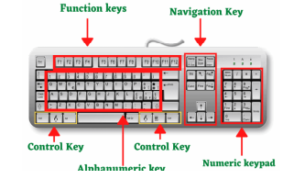

* **Categories of Keys on a Keyboard**

The buttons on the keyboard of the computer are called keys. Generally, a keyboard has 104 or more keys. A keyboard has different groups of keys such as Alphabet keys Numeric keys and Function keys.

**Alphabet Keys**

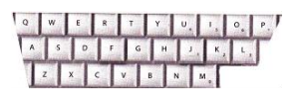The alphabet keys are, A, B, C... Z. These keys help us to write words and sentences on the computer. In English there are 26 alphabets from A to Z that’s why there are 26 alphabet keys on the keyboard.

**Numeric Keys**

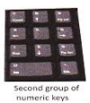

A numeric keypad, number pad, numpad, or ten key, is the palm-sized, usually-17-key section of a standard computer keyboard, usually on the far right. It provides calculator-style efficiency for entering numbers.

**Function Keys**

****A keyboard usually has 12 function keys from F1 to F12. The function of each key is unique and their function are depended on the operating system installed in the computer.

**Other Important Keys**

In addition to the keys discussed above there are some other important keys which have special purpose.

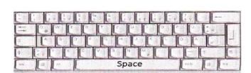

**Space** **Bar**

Space Bar helps us to give space between the words. It is the longest key on the keyboard.

**Shift** **Key**

This key helps you to type the signs marked on top of the numeric keys and also used to type, ,?,:,"", {, }. To type the capital letter, the keys combination shift and key of that letter are used.

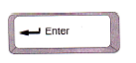**Enter** **Key**

This key helps us to move the cursor to the next line. While typing, you just press the Enter key to start writing from a new line. Another function of Enter Key is pressed to execute the given command.

**Backspace** **Key**

If you have written something wrong on the computer, you can erase it by using the backspace key. This key helps to erase the letters to the left side of the cursor. The cursor is the blinking line that you see on the screen of the computer. It looks like.

**Delete** **Key**

This key helps to erase the letters to the right side of the cursor. Sometime, the delete key with other keys is pressed for performing an operation, such as, the keys combination, Ctrl + Alt + Delete are used for booting the computer again.

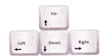**Arrow Keys**

The arrow keys help in moving the cursor in all the directions (left, right, up or down). Hence, they are also called cursor control keys. There are four arrow keys on the keyboard.

**What are the Uses of Keyboard in Computer?**

There are five uses of a keyboard in a computer, which are given below.

1. Input Date

2. Type Numbers

3. Text Chatting

4. Type Special Character

5. Types computer short cut Keys

**Types of Keyboards**

**Gaming Keyboard**

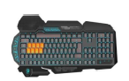If you are dedicated to playing games on your PC, you may invest in a common keyboard and use it for a few days. But if you really want to take your favorite games to the next level, a gaming keyboard can come in handy. Gaming keyboards are specifically designed to enhance your gaming experience and increase your wins. These types of keyboards are geared toward users who spend hours while playing computer games.

**Ergonomic Keyboard**

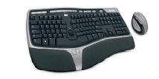Ergonomic keyboards are not really a normal type of computer keyboard on their own, but rather refer to any keyboard that is designed to minimize stress and pain on your body and enhance comfort.

**Multimedia Keyboard**

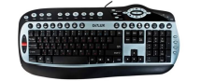Multimedia keyboards are very similar to common keyboards but with the addition of a series of keys that allow you to control directly the most common functions of multimedia content players, such as Play, Stop, Resume, Rewind, Mute, Volume, etc.

**Hand** **Keyboard**

Some keyboards look so unconventional cause they create a whole new category. Such as the Alpha Grip handheld keyboard, which combines the design of a game controller with the functions of a basic keyboard and ergonomic keyboard too.

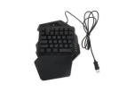

**Flexible Keyboards**

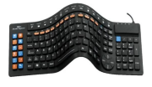These keyboards are very eye-catching for those who see them for the first time, stand out for their appearance and the material with which they are built by rubber, silicon and plastic.

**Unique Features**

The first fact is that they are waterproof in general. These keyboards are designed to resist splashing and total immersion in water.

**Wireless Keyboard**

The second one is wireless keyboards, which connect to the terminal with wireless signals like WiFi or via Bluetooth, without any need for wire cable.

**Laser Virtual Keyboards**

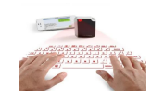Imagine being able to use any flat surface for writing. For devices that don’t have a built-in physical keyboard, like your phone or tablet, this could be a boon. We are talking about an optical virtual keyboard appear on the screen, or as it is popularly known, a virtual keyboard.

**Five Functions of Keyboard**

**Built-in functions**

Two common built-in functions are the Home and End keys. Pressing "Home" in any type of edit window will cause the cursor to jump to the beginning of the line you are editing, and pressing "End" will move the cursor to the end of the line. These functions are built into most every PC keyboard.

**Boot sequence functions**

When your PC is first booted up, the keyboard has a few important functions built into the BIOS, the interface between you and your computer. Commonly, the boot functions are F1 to continue, ESC to exit the current command, and F2 to enter the system setup. Keep in mind that the BIOS setup deals exclusively with the computer hardware and changes made to the BIOS could make the computer inoperable without major repairs.

**Operation keystrokes**

A large number of computer programs use the F1 key as a universal help key. Likewise, pressing the ESC key will usually take you back to the previous step. Other function keys--F1 through F12--have typical functions, such as F8 saving a document. It is important to note that these functions are set by individual programs, and will vary from one application to the next.

**Shortcut commands**

Some keyboards now have specialty keys that give the user the ability to launch Internet functions or common computer programs. Your keyboard may have specialty keys that will launch your web browser, an email program or a chat program. You also may have keys that will launch your computer's calculator or shut down your computer.

**Other Functions of Keyboard**

There are various other functions of keyboard, which are given below.

1. Print Screen

2. Scroll Lock

3. Pause

4. Brightness UP & Down

5. Volume UP & Down